## DELIVERABLES

**1. Examine the files and determine an appropriate relationship model between them.  Create and document a physical data model detailing the field types and relationships.**

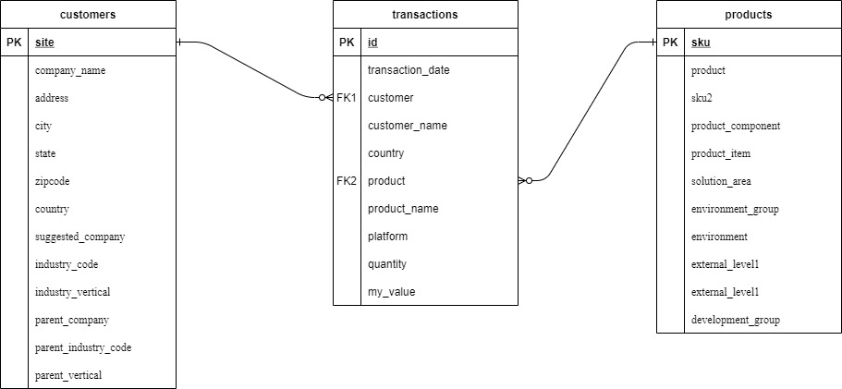

**Customer Table**

|  |  |  |  |
| --- | --- | --- | --- |
| Sno | Column Name | Data type | Constraints |
| 1 | Site | Int | Primary Key , Unique, Not null |
| 2 | Company Name | Varchar (255) | Not Null |
| 3 | Address | Varchar (255) | Not Null |
| 4 | City | Varchar (255) | Not null |
| 5 | State | Varchar (255) | Not Null |
| 6 | Zipcode | Varchar (255) | Not null |
| 7 | Country | Varchar (255) | Not null |
| 8 | Suggested_company | Varchar (255) | Not null |
| 9 | Industry_code | Varchar (255) | Not null |
| 10 | Industry_vertical | Varchar (255) | Not null |
| 11 | Parent_company | Varchar (255) | Not null |
| 12 | parent_industry_code | Varchar (255) | Not null |
| 13 | Parent_vertical | Varchar (255) | Not null |

**Product Table**

|  |  |  |  |
| --- | --- | --- | --- |
| Sno | Column Name | Data type | Constraints |
| 1 | sku | Int | Primary Key , Unique, Not null |
| 2 | Product | Varchar (255) | Not Null |
| 3 | Sku2 | Varchar (255) | Not Null |
| 4 | Product_component | Varchar (255) | Not null |
| 5 | Product_item | Varchar (255) | Not Null |
| 6 | Solution_area | Varchar (255) | Not null |
| 7 | Environment_group | Varchar (255) | Not null |
| 8 | Environment | Varchar (255) | Not null |
| 9 | External_level1 | Varchar (255) | Not null |
| 10 | External_level2 | Varchar (255) | Not null |
| 11 | Development_group | Varchar (255) | Not null |

**Transaction Table**

|  |  |  |  |
| --- | --- | --- | --- |
| Sno | Column Name | Data type | Constraints |
| 1 | id | Int | Primary Key , Unique, Not null |
| 2 | Transaction_date | Date_time | Not Null |
| 3 | Customer | In | Not Null, Foreign key |
| 4 | Customer_name | Varchar (255) | Not null |
| 5 | Country | Varchar (255) | Not Null |
| 6 | Product | Varchar (255) | Not null |
| 7 | Product_name | Varchar (255) | Not null |
| 8 | Platform | Varchar (255) | Not null |
| 9 | Quantity | Int | Not null |
| 10 | My_value | Int | Not null |

**2. Load all four Three into a new database schema, and provide evidence of loading scripts and row counts.**

Codes are provided in

1. customers.sql file

2. products.sql

3. transactions.sql

**3. Ensure that the data is clean, describe the steps taken, and if you need to remove some of it, explain why that is the case.**

1. DELETE FROM customers WHERE company_name=''

This query will remove all the empty row from the table customers where company_name is empty

2. DELETE FROM customers WHERE suggested_company='';

This query will remove all the empty row from the table customers where suggested_company is empty

3. DELETE FROM customers WHERE state='';

This query will remove all the empty row from the table customers where state is empty

4. DELETE FROM products WHERE sku2='';

This query will remove all the empty row from the table products where sku is empty

5. DELETE FROM transactions WHERE customer='';

This query will remove all the empty row from the table transactions where customer is empty

6. DELETE FROM transactions WHERE product='';

This query will remove all the empty row from the table transactions where product is empty

SQL Queries

1. How many **different** products do the company sell

I am assuming that the company name is “Alltel Communications LLC” the products I’m searching for.

SELECT t.customer_name,p.* FROM transactions as t INNER JOIN customers as c ON c.site=t.customer INNER JOIN products as p ON p.sku2=t.product WHERE c.company_name=' Alltel Communications LLC';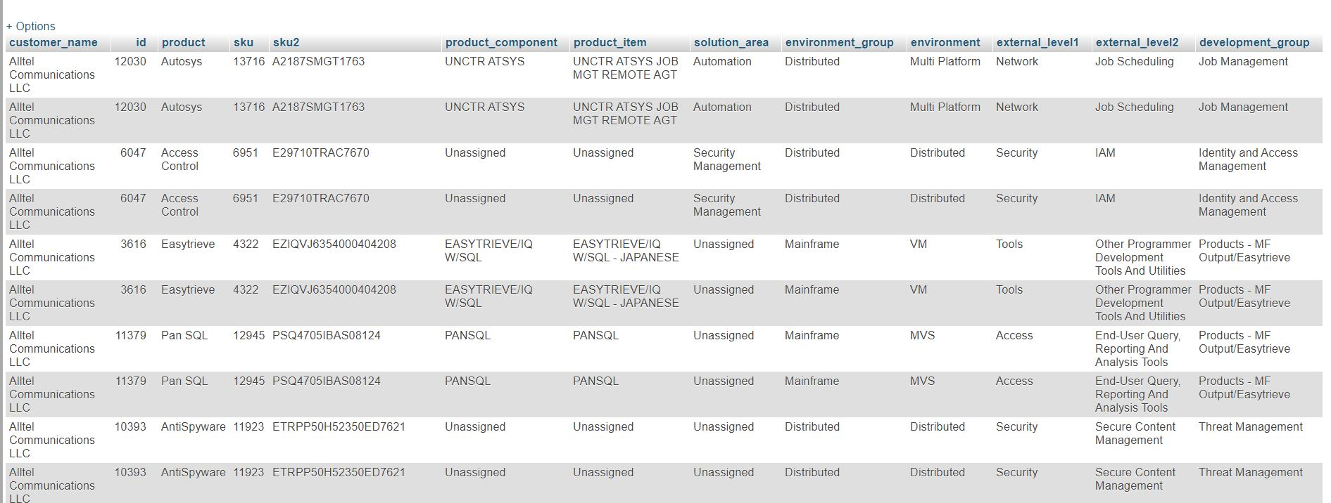

2. How many products have the company sold in October?

I am assuming that the company name is “Alltel Communications LLC” the products I’m searching for.

SELECT t.customer_name,t.transaction_date,p.* FROM transactions as t INNER JOIN customers as c ON c.site=t.customer INNER JOIN products as p ON p.sku2=t.product WHERE c.company_name=' Alltel Communications LLC' and t.transaction_date BETWEEN date('2014-10-01') AND date('2014-10-31');

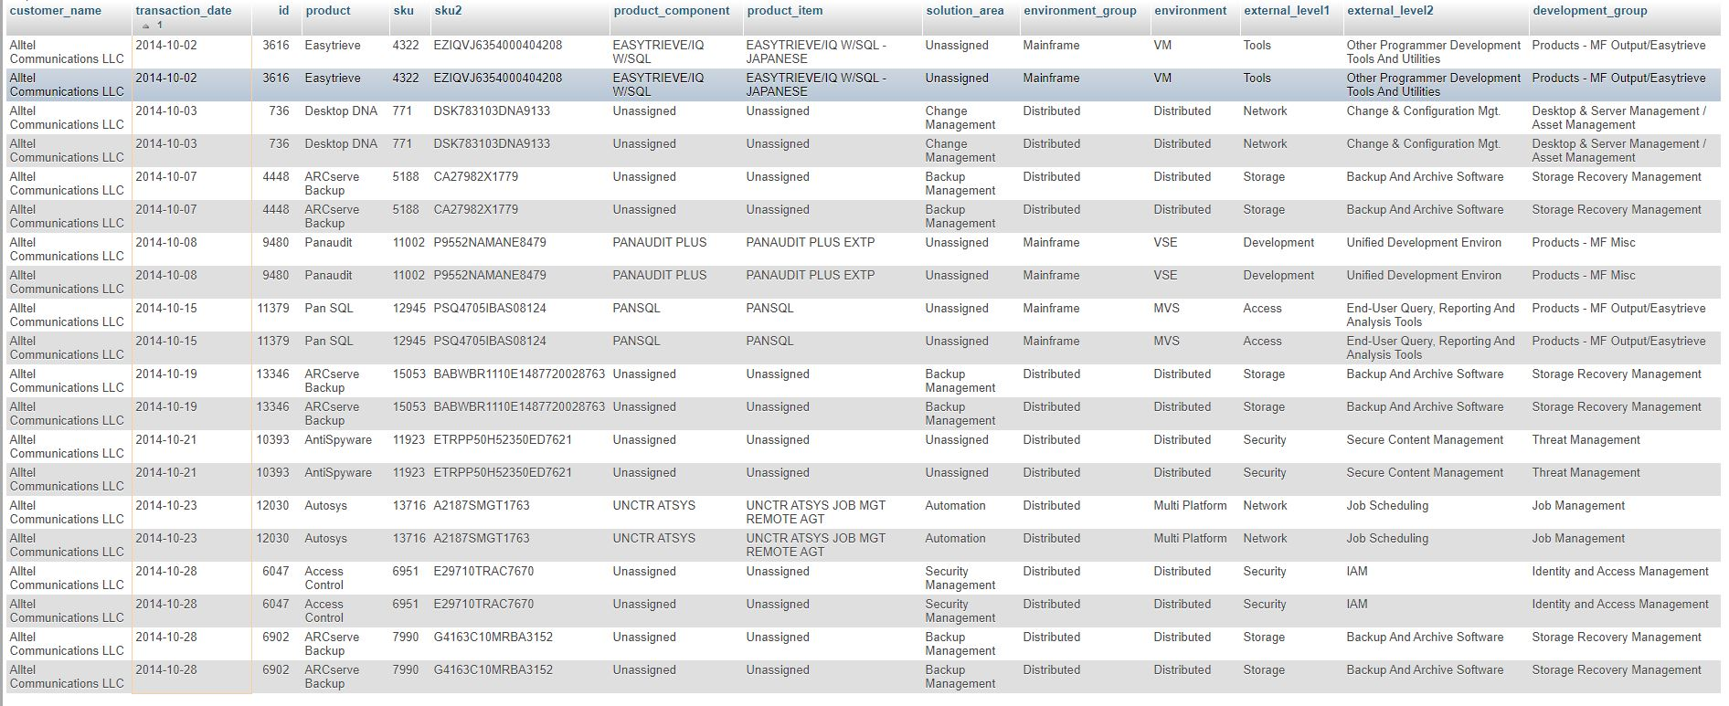

3. How many customers have bought products from the company in October?

SELECT t.transaction_date,t.customer_name,p.* FROM transactions as t INNER JOIN customers as c ON c.site=t.customer INNER JOIN products as p ON p.sku2=t.product WHERE c.company_name=' Alltel Communications LLC' and t.transaction_date BETWEEN date('2014-10-02') AND date('2014-10-31')

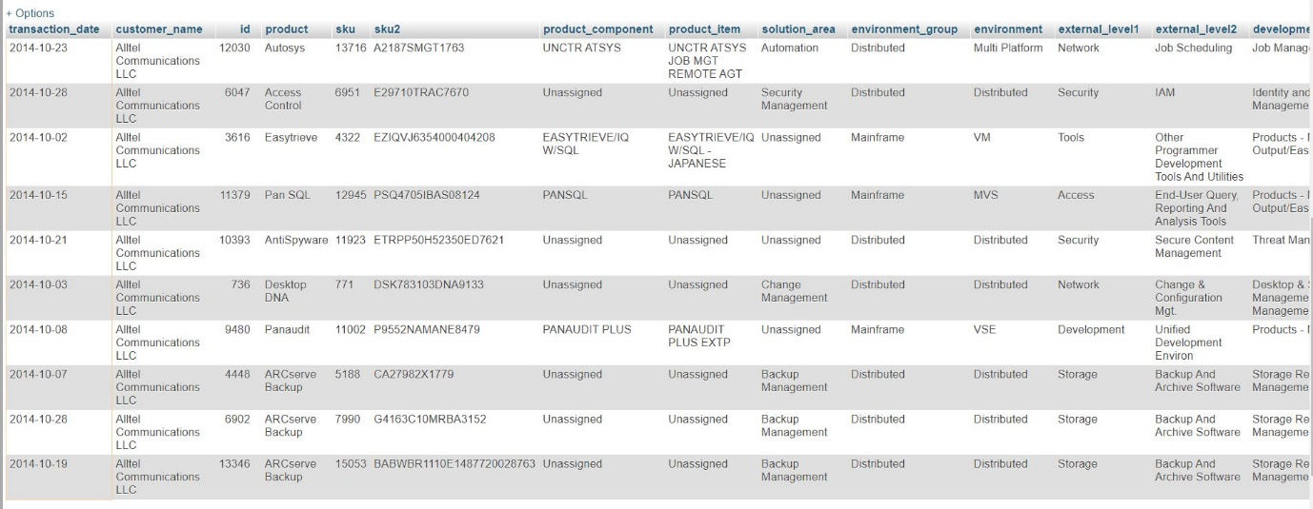

4. Which customer has spent the most money with the company in October?

SELECT customer_name,SUM(my_value) as total_amount FROM transactions WHERE transaction_date BETWEEN date('2014-10-01') and date('2014-10-31') GROUP BY customer_name ORDER BY customer_name ASC LIMIT 1;

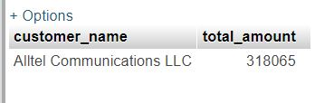

5 How many countries did the company ship products to in October

SELECT country,COUNT(country) as no_of_shipments FROM transactions WHERE transaction_date BETWEEN date('2014-10-01') and date('2014-10-31') GROUP BY country ORDER BY country ASC

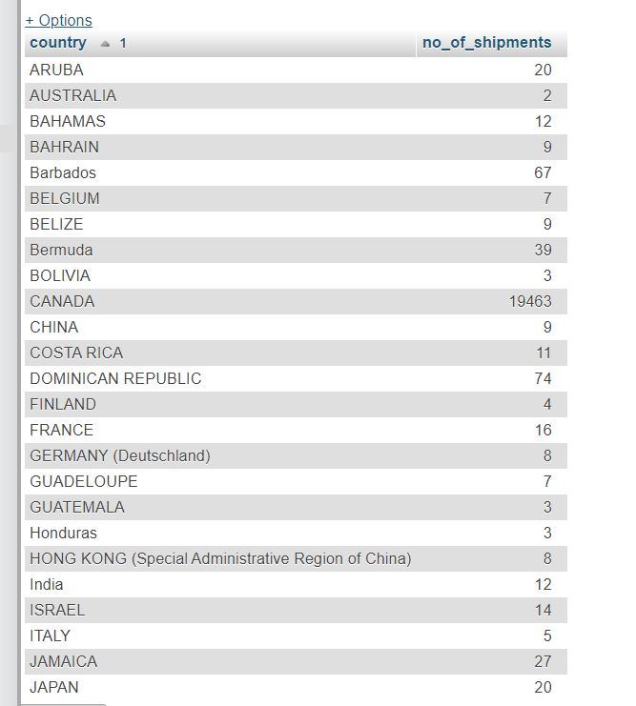

6. Which state in America has the highest number of registered customers

SELECT state,COUNT(state) as no_of_customers FROM customers WHERE country='UNITED STATES' and state<>'' GROUP BY state ORDER BY no_of_customers DESC LIMIT 1;

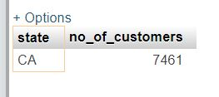

7. Which solution area has the most product sku’s within it

SELECT solution_area, COUNT(solution_area) as count_of_product FROM products GROUP BY solution_area ORDER BY count_of_product DESC LIMIT 1

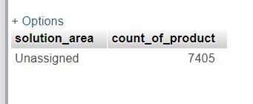

8. On which day were the most products sold

SELECT transaction_date,product_name,COUNT(transaction_date) as no_of_product_sell FROM transactions GROUP BY transaction_date,product_name ORDER BY no_of_product_sell DESC LIMIT 1;

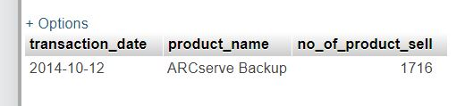

9. Which development group had the most sales in October

SELECT p.development_group,COUNT(p.development_group) as number_of_sales FROM transactions as t INNER JOIN products as p ON p.sku2=t.product WHERE t.transaction_date BETWEEN date('2014-10-01') and date('2014-10-31') GROUP BY p.development_group ORDER BY number_of_sales DESC LIMIT 1;

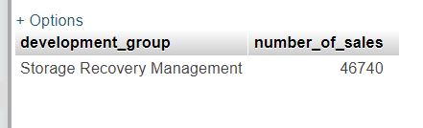

10. Which industry vertical had the lowest number of sales in October

SELECT c.industry_vertical,COUNT(c.industry_vertical) as no_of_sales FROM customers as c INNER JOIN transactions as t ON t.customer=c.site WHERE t.transaction_date BETWEEN date('2014-10-01') and date('2014-10-31') GROUP BY c.industry_vertical ORDER BY no_of_sales ASC LIMIT 1

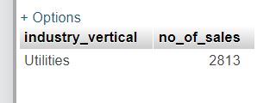

11. Which solution area has the lowest number of sales in the Retail industry vertical

SELECT solution_area, COUNT(solution_area) as sale_of_product FROM products GROUP BY solution_area ORDER BY sale_of_product ASC LIMIT 1

